STORE WEBSITE FOR COLLEGE USING FULL STACK


Major/Mini Project submitted in partial fulfillment of the requirement for the award of the
degree of

BACHELOR OF TECHNOLOGY

IN

COMPUTER SCIENCE AND ENGINEERING

Under the esteemed guidance of

Mr. G. PRAVEEN KUMAR
Associate Professor, CSE DEPT

By

P VIVEKVARDHAN (19R11A0583)
K GUNA (19R11A0570)
PVN SIDDHARTHA (19R11A0584)



Department of Computer Science and Engineering
Accredited by NBA

Geethanjali College of Engineering and Technology
(UGC Autonomous)
(Affiliated to J.N.T.U.H, Approved by AICTE, New Delhi)
Cheeryal (V), Keesara (M), Medchal.Dist.-501 301.

Geethanjali College of Engineering & Technology
(UGC Autonomous)
(Affiliated to JNTUH, Approved by AICTE, New Delhi)
Cheeryal (V), Keesara(M), Medchal Dist.-501 301.

DEPARTMENT OF COMPUTER SCIENCE AND ENGINEERING
Accredited by NBA



Certificate

This is to certify that the B.Tech Main Project report entitled “ STORE WEBSIE FOR COLLEGE USING FULL STACK ” is a bonafide work done by P VIVEKVARDHAN (19R11A0583), K GUNA (19R11A0570), PVN SIDDHARTHA (19R11A0584), in partial fulfillment of the requirement of the award for the degree of Bachelor of Technology in “Computer Science and Engineering” from Jawaharlal Nehru Technological University, Hyderabad during the year 2022-2023.

Internal Guide HOD-CSE

G. Praveen Kumar Dr. A. Sree lakshmi
Associate Professor
CSE Dept.

Geethanjali College of Engineering & Technology
(UGC Autonomous)
(Affiliated to JNTUH Approved by AICTE, New Delhi)
Cheeryal (V), Keesara(M), Medchal Dist.-501 301.

DEPARTMENT OF COMPUTER SCIENCE AND ENGINEERING
Accredited by NBA

DECLARATION BY THE CANDIDATE

We, P VIVEKVARDHAN, K GUNA, PVN SIDDHARTHA bearing Roll Nos. 19R11A0583, 19R11A0570, 19R11A0584, hereby declare that the project report entitled “STORE WEBSITE FOR COLLEGE USING FULL STACK” is done under the guidance of Mr. G. PRAVEEN KUMAR, Associate Professor, Department of Computer Science and Engineering, Geethanjali College of Engineering and Technology, is submitted in partial fulfillment of the requirements for the award of the degree of Bachelor of Technology in Computer Science and Engineering.
This is a record of bonafide work carried out by us in {Name of the Institute where you have done your project] and the results embodied in this project have not been reproduced or copied from any source. The results embodied in this project report have not been submitted to any other University or Institute for the award of any other degree or diploma.
P VIVEKVARDHAN (19R11A0583),
K GUNA (19R11A0570),
PVN SIDDHARTHA (19R11A0584)
Department of CSE,
Geethanjali College of Engineering and
Technology Cheeryal.
ACKNOWLEDGEMENT

ABSTRACT

The Store is a web-based application intended for college store users. The main objective of this application is to make it interactive and its ease of use. It would make searching, viewing and selection of a product easier. It contains a sophisticated search engine for users to search for products specific to their needs. The search engine provides an easy and convenient way to search for products where a user can search for a product interactively and the search engine would refine the products available based on the user’s input. The user can then view the complete specification of each product. The application also provides a drag and drop feature so that a user can add a product to the shopping cart by dragging the item in to the shopping cart. The main emphasis lies in providing a user-friendly website for the college store which helps the people to search for a specific product in an easy way and updating the details of the product in the website.

FIGURE NO | PAGE NO
LIST OF FIGURES

LIST OF SCREENS
SCREEN NO | PAGE NO

LIST OF ABBREVIATIONS

TABLE OF CONTENTS

SNO | CONTENT | PAGE NO.
- ABSTRACT
- LIST OF FIGURES
- LIST OF TABLES
- LIST OF SCREENS
- LIST OF SYMBOLS & ABBREVIATIONS
1 | INTRODUCTION  - ABOUT THE PROJECT  - OBJECTIVE
2 | SYSTEM ANALYSIS  - EXISTING SYSTEM  - PROPOSED SYSTEM  - DETAILS  - IMPACT ON ENVIRONMENT  - SAFETY  - ETHICS  - COST  - TYPE  - STANDARDS  - SCOPE OF THE PROJECT  - MODULES DESCRIPTION  - SYSTEM CONFIGURATION
3 | LITERATURE OVERVIEW
4 | SYSTEM DESIGN  - SYSTEM ARCHITECTURE  - UML DAGRAMS  - SYSTEM DESIGN
5 | SAMPLE CODE
6 | TESTING  - TESTING  - TEST CASES
7 | OUTPUT SCREENS
8 | CONCLUSION  - CONCLUSION  - FURTHUR ENHANCEMENTS
9 | BIBLIOGRAPHY  - BOOKS REFERENCES  - WEBSITE REFERENCES  - TECHNICAL PUBLICATION REFERENCES
10 | APPENDICES  - SW USED  - METHODOLOGIES USED  - TESTING METHODS USED
11 | PLAGIARISM REPORT

INTRODUCTION
1.1 ABOUT THE PROJECT
This project is a web-based shopping system for an existing shop in our college. The project objective is to deliver the online shopping application. Online shopping is the process whereby consumers directly buy goods or services from a seller in real-time, without an intermediary service, over the Internet. It is a form of electronic commerce. The objective of this project is to create an online shopping system web portal with a content management system which would allow product information to be updated securely using a web application. This system is user-friendly as no one needs to go to the market physically. So mostly it is not difficult to get the product as per our desire. Description About the products is limit and is mostly verbal and pictorial. For this type of shopping, one needs to have an ample amount of free time. The web portal will have an online interface in the form of an online shopping system website that will allow users to buy products from the store. This project is an attempt to provide the advantages of online shopping to customers of a real shop. It helps buying the products in the shop anywhere through internet by using an Internet browser. Thus, the customer will get the service of online shopping and can order products from the web application.

1.2 Objective
The objective of the project is to make an application to purchase items in an existing shop. In order to build such an application complete web support is needed. A complete and efficient web application which can provide the online shopping experience is the basic objective of the project. The web application can be implemented in the form of a web portal. The project is totally built at administrative end and thus only the administrator is guaranteed the access. The purpose of the project is to build an application program to reduce the manual work for managing the products. It tracks all the details about the customer. The main aim of this project is to provide online records to the administrator and the ease of collecting necessary items for the students those who require it.

2.System Analysis

2.1 Existing System
The current system for buying products from store is to visit the shop manually and from the available product choose the item customer want and buying the item by payment of the price of the item.
- It is less user-friendly.
- User must go to shop and select products.
- Description of the product limited.
- It is a time-consuming process.
- Not in reach of distant user.

  - Proposed System
2.2.1 Details
- We have created a website were all the available products in the store are displayed in the web application.
- Each product availability is also mentioned along with the product image.
- Two sections were created (i) Administrator (ii) Student.
- Administrator takes care of all the updation of the products availability and also keeps track of the users who ordered.
- Student can select the item they want and order them from web application anywhere and anytime.
- If the administrator wants all the list of students ordered then a option will be given where he can download a PDF file which contains the track of students ordered.
- Month wise tracking is also done.

2.2.2 Impact on Environment
In the post-pandemic world, people care far more about health and the environmental impact on it. As a result, consumer demand for effective wellness tools that empower actionable decision-making has exploded. As environmental reporting methods improve and an increased emphasis gets placed on the impact of environmental exposure on person’s wellbeing, personalized health-focused environmental insights have become a hot commodity.

2.2.3 Safety
Store website is a secured application where the data provided by the users is kept safe with us. We constantly monitor and work towards closing any threats that might put it at any risk. Our application will not display any disturbing advertisements or pop ups.

2.2.4 Ethics
We have followed the general SW ethics like securing privacy information of the resources using application, not harming anybody physically or virtually and maintaining confidentiality.

2.2.5 Cost
Since the project mainly involves coding and implementing it as an application, this project is economically feasible to implement. Also, all the resources used are open source, available easily on the internet. It is cost effective.

2.2.6 Type
Ours is an application which can be used when the user has an internet connection. This is a web application created using JavaScript ,HTML, CSS and PHP.

2.2.7 Standards
Software processes can deal with many challenges facing the web development process. These challenges include volatility of requirements, strong user involvement, development time tightness, process simplicity, and production of valuable software at low cost. Store Website Using Full Stack was created using water fall model.
Waterfall approach was first SDLC Model to be used widely in Software Engineering to ensure success of the project. In "The Waterfall" approach, the whole process of software development is divided into separate phases. In this Waterfall model, typically, the outcome of one phase acts as the input for the next phase sequentially. The following illustration is a representation of the different phases of the Waterfall Model.
SDLC Waterfall Model
The sequential phases in Waterfall model are –
Requirement Gathering and analysis
All possible requirements of the system to be developed are captured in this phase and documented in a requirement specification document.
System Design
The requirement specifications from first phase are studied in this phase and the system design is prepared. This system design helps in specifying hardware and system requirements and helps in defining the overall system architecture.

Implementation
With inputs from the system design, the system is first developed in small programs called units, which are integrated in the next phase. Each unit is developed and tested for its functionality, which is referred to as Unit Testing.
Integration and Testing
All the units developed in the implementation phase are integrated into a system after testing of each unit. Post integration the entire system is tested for any faults and failures. Deployment of system Once the functional and non-functional testing is done; the product is deployed in the customer environment or released into the market. If any issues arises in the client side or in the administrator side it will be fixed or troubleshooted. If one testing side fails then the whole process is checked once again.
Maintenance
There are some issues which come up in the client environment. To fix those issues, patches are released. Also, to enhance the product some better versions are released. Maintenance is done to deliver these changes in the customer environment. All these phases are cascaded to each other in which progress is seen as flowing steadily downwards (like a waterfall) through the phases. The next phase is started only after the defined set of goals are achieved for previous phase and it is signed off, so the name "Waterfall Model". In this model, phases do not overlap.
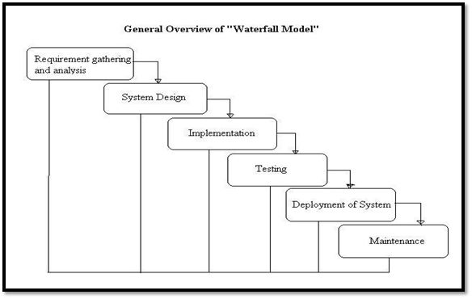
Figure (2.2.7): Waterfall model

2.3 Scope Of The Project
- The proposed system can be further optimized to provide ease of purchasing products. This module can be deployed in various operating systems and web applications.
- Different areas can implement our prospect of providing the parameters discussed.
- Students can easily order there products from the website and they can see the product description and by entering the size and quantity they want without physically going to the store and purchasing items.
- The main scope is to reduce the time, efforts and also making things easily available through web application.
- This is more user-friendly, cost effective and also students can order products anywhere and anytime.
2.4 Modules Description
There are three modules in our project. They are listed below with detailed descriptions.
- Input Module.
- Processing Module.
- Output Module.
Input Module : Takes the user name and password for the administrator section.
Processing Module : The user name and password are checked with the database and if they are correct then it redirects to the next page and in the other hand students should fill all the fields for ordering products.
Output Module : Make sures that the student details are inserted into the database and also when administrator changes the availability then all the other pages should also get changed.

2.5 System Configuration
Software Requirements
- IDE : Atom editor
- Libraries : JavaScript Libraries
- Tools : Favicon
- External Links : Fonts.io (Images)
- Operating System : Windows 7 or above
Hardware Requirements
- RAM : 64 MB (or) Higher
- Cache : 512 MB

Literature Overview

The history of ecommerce shopping carts began immediately after the World Wide Web, or WWW, became a major medium to communicate information around the world. Ecommerce shopping-cart applications allow consumers to buy goods or services directly over the internet using a web browser. This online shopping evokes the business-to-consumer (B2C) process where a consumer buys directly from the business. The process where a business buys from another business is called a business-to-business (B2B) process. The best examples of shopping cart applications using B2B process are eBay and Amazon, both of which were launched in 1995. At present, most users of these online shopping-cart applications are people who have higher levels of education, have exposure to technological advancements, and are in a better income group. Such users develop a positive attitude towards these convenient shopping techniques. According to a study in December 2011, Equation Research surveyed 1,500 online shoppers and found that 87% of tablet owners made online transactions during the early Christmas shopping season. Building a new successful shopping cart is simple because of high competition in the market, and the designer of a shopping-cart application must consider the information load, complexity, and novelty. Complexity refers to the number of features available on the shopping cart and the levels of marketing, whereas novelty involves the unexpected or unfamiliar aspects of the site. A designer must also consider the consumers’ needs and expectations.
A user-friendly design is very critical to the success of any shopping-cart application because, unlike physical stores, consumers at online stores come from all ages, genders, and cultures. Logistics clearly says that, to have a successful and profitable online shopping application, businesses have to spend a significant amount of time and money for designing, developing, testing, and maintaining the application. Apart from the high-class design and user interface, a good practice needs to be done to provide quality customer service. A typical shopping cart should contain certain features such as adding items to the cart and checking out those items using the available payment methods. Most shopping-cart applications are implemented using HTTP cookies or query strings, and an HTML setup is required to install the shopping cart on the servers that ultimately hosts the site on the internet. Most of these server-based applications require data related to the items added in the shopping cart to be kept in a session object which can be accessed later and manipulated dynamically because the users can add or remove one or more items from the cart. Most simple shopping-cart applications do not allow checkout to be done before any items are added to the cart. Data are often stored in an external database or application-based databases which can be accessed in real time by the application administrator. There are many examples of online shopping applications developed in different languages. Choosing a development platform and language depends on policies set by the company for which the application is being designed. It also depends on several other factors which are very important when considering the platform to design an application, for example, how portable the application will be after being built or if the application is open sourced. Java is chosen for this application because various reasons: it is a simple, robust, and cross-platform language. Applications written in Java can be transported and run on any environment, be it MAC or Linux, because Java programs are compiled into platform-independent byte codes. Because of the robustness of Java, it is a very safe language, as they provide exception handling and a layer method to communicate with the database, which prevents the system from crashing easily. Another very important factor from the development point of view is that the Java language is object oriented, where everything is treated as an object and where class methods are implemented instead of functions or procedures, which makes it very simple to understand the code.
This application performs all the basic functions that the above-mentioned applications do, such as selecting an item and adding it to the shopping cart, user login or registering, checkout of the item, etc. Other functions that can be added to this application are proposed in the future work, and they would be necessary under a more complete and complex design. The final application is expected to teach students enough to start them on a course to implement more complex functionalities, as mentioned in the Future Work.

Some of the main technologies used in developing this project are mentioned below
JAVA SCRIPT
JavaScript is a client-side language, which technically makes it a front-end language. But with the Node.js framework, JavaScript can also be used in back-end. Using JavaScript across the whole stack, for both front-end and back-end, is an excellent practice because it creates a cohesive application. When as much code as possible is all in the same language, it makes it easier to maintain, manage, update, and build with a single team.
HTML
HTML stands for Hyper Text Markup Language. It is used to design web pages using the markup language. HTML is the combination of Hypertext and Markup language. Hypertext defines the link between the web pages and markup language defines the text document within the tag that define the structure of web pages. HTML is used to create the structure of web pages that are displayed on the World Wide Web (www). It contains Tags and Attributes that are used to design the web pages. Also, we can link multiple pages using Hyperlinks.
CSS
CSS(Cascading Style Sheet) is used to apply styles to web pages. Cascading Style Sheets are fondly referred to as CSS. It is used to make web pages presentable. The reason for using this is to simplify the process of making web pages presentable. It allows you to apply styles on web pages. More importantly, it enables you to do this independently of the HTML that makes up each web page.
ATOM
Atom is a lightweight but powerful source code editor which runs on your desktop and is available for Windows, macOS and Linux. It comes with built-in support for JavaScript, TypeScript and Node.js and has a rich ecosystem of extensions for other languages and runtimes (such as C++, C#, Java, Python, PHP, Go, .NET).

4. System Design

4.1 System Architecture

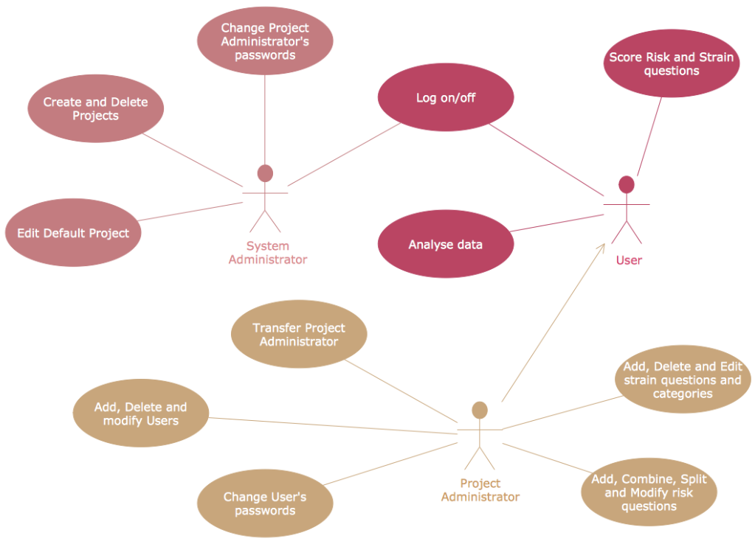

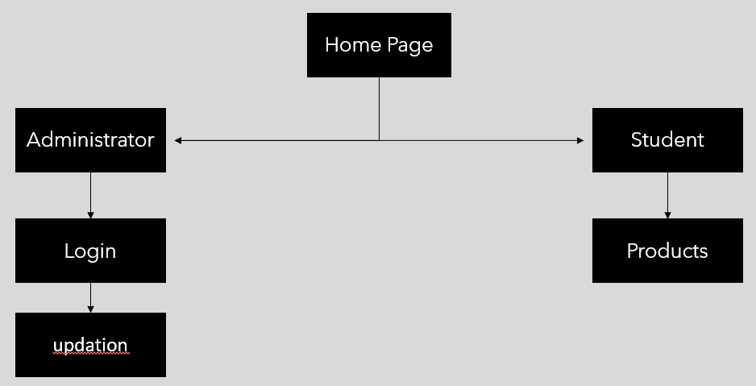
Figure (4.1) : Architectural Layer
4.2 UML Diagrams
4.2.1 Class Diagram
A class diagram in the Unified Modeling Language (UML) is a type of static structure diagram that describes the structure of a system by showing the system's classes, their attributes, operations (or methods), and the relationships among objects.

5. Sample Code
Index.html
<!DOCTYPE html>
<html lang="en" dir="ltr">
<head>
<meta charset="utf-8">
<title>Store</title>
<link rel="stylesheet" href="Css.css">
</head>
<body>
<div class="gcet">
<img src="Gcet-logo.png">
</div>
<section>
<div class="container">
<div class="card">
<div class="content">
<div class="imgBx">
<img src="https://cdn-icons-png.flaticon.com/512/3079/3079976.png">
</div>
<div class="contentBx">
<h3>Administrator</h3>
</div>
</div>
<ul class="sci">
<li>
<a href="Login.html">Click here</a>
</li>
</ul>
</div>
<div class="card">
<div class="content">
<div class="imgBx">
<img src="https://cdn-icons-png.flaticon.com/512/3135/3135810.png">
</div>
<div class="contentBx">
<h3>Student</h3>
</div>
</div>
<ul class="sci">
<li>
<a href="Student.html">Click here</a>
</li>
</ul>
</div>
</div>
</section>
</body>
</html>

Student.html
<!DOCTYPE html>
<html lang="en" dir="ltr">
<head>
<meta charset="utf-8">
<title>Student</title>
<link rel="stylesheet" href="Student.css">
</head>
<body>
<section>
<div class="container">
<div class="card">
<div class="content">
<div class="imgBx">
<img src="https://cdn-icons-png.flaticon.com/128/2390/2390043.png">
</div>
<div class="contentBx">
<h3>Apron<br><br><br>Available - 40</h3>
</div>
</div>
<ul class="sci">
<li>
<a href="Apron.html">Click here</a>
</li>
</ul>
</div>
<div class="card">
<div class="content">
<div class="imgBx">
<img src="https://cdn-icons-png.flaticon.com/128/1773/1773049.png">
</div>
<div class="contentBx">
<h3>Manual<br><br><br>Available - 40</h3>
</div>
</div>
<ul class="sci">
<li>
<a href="">Click here</a>
</li>
</ul>
</div>
<div class="card">
<div class="content">
<div class="imgBx">
<img src="https://cdn-icons-png.flaticon.com/512/2541/2541988.png">
</div>
<div class="contentBx">
<h3>Chart sheet<br><br><br>Available - 40</h3>
</div>
</div>
<ul class="sci">
<li>
<a href="">Click here</a>
</li>
</ul>
</div>
<div class="card">
<div class="content">
<div class="imgBx">
<img src="https://cdn-icons-png.flaticon.com/128/2132/2132217.png">
</div>
<div class="contentBx">
<h3>Assignment book<br><br><br>Available - 40</h3>
</div>
</div>
<ul class="sci">
<li>
<a href="">Click here</a>
</li>
</ul>
</div>
</div>
</section>
</body>
</html>

Demo.html
<!DOCTYPE html>
<html lang="en">
<head>
<meta charset="UTF-8">
<meta http-equiv="X-UA-Compatible" content="IE=edge">
<meta name="viewport" content="width=device-width, initial-scale=1.0">
<title>Document</title>
<link rel="stylesheet" href="demo.css">
</head>
<body>
<div class="ch">
<a href="retrieval.php">CLICK HERE</a>
</div>
<section>
<div class="container">
<div class="card">
<div class="content">
<div class="imgBx">
<img src="https://cdn-icons-png.flaticon.com/128/2390/2390043.png">
</div>
<div class="contentBx">
<h3>Apron<br><br><br></h3>
<input id=demoInput type=number min=0 max=10000>
<button onclick="increment()">+</button>
<button onclick="decrement()">-</button>
<script>
function increment() {
document.getElementById('demoInput').stepUp();
}
function decrement() {
document.getElementById('demoInput').stepDown();
}
</script>
</div>
</div>
</div>
<div class="card">
<div class="content">
<div class="imgBx">
<img src="https://cdn-icons-png.flaticon.com/128/1773/1773049.png">
</div>
<div class="contentBx">
<h3>Manual<br><br><br>Available - 40</h3>
</div>
</div>
<ul class="sci">
<li>
<a href="">Click here</a>
</li>
</ul>
</div>
<div class="card">
<div class="content">
<div class="imgBx">
<img src="https://cdn-icons-png.flaticon.com/512/2541/2541988.png">
</div>
<div class="contentBx">
<h3>Chart sheet<br><br><br>Available - 40</h3>
</div>
</div>
<ul class="sci">
<li>
<a href="">Click here</a>
</li>
</ul>
</div>
<div class="card">
<div class="content">
<div class="imgBx">
<img src="https://cdn-icons-png.flaticon.com/128/2132/2132217.png">
</div>
<div class="contentBx">
<h3>Assignment book<br><br><br>Available - 40</h3>
</div>
</div>
<ul class="sci">
<li>
<a href="">Click here</a>
</li>
</ul>
</div>
</div>
</section>
<div class="frm">
<form action="retrieval1.php" method="POST">
<select name="month">
<option value="" disabled selected>CHOOSE OPTION</option>
<option value="January">JAN</option>
<option value="February">FEB</option>
<option value="March">MAR</option>
<option value="April">APR</option>
<option value="May">MAY</option>
<option value="June">JUN</option>
<option value="July">JUL</option>
<option value="August">AUG</option>
<option value="September">SEP</option>
<option value="October">OCT</option>
<option value="November">NOV</option>
<option value="December">DEC</option>
</select>
<br><br>
<input type="submit" name="search" value="search">
</form>
</div>
</body>
</html>

Css.css
* {
margin: 0;
padding: 0;
}
body {
display: flex;
justify-content: center;
align-items: center;
flex-wrap: wrap;
background: #161616;
min-height: 100vh;
}
.gcet
{
position: absolute;
top: 25px;
}

section::before {
content: '';
position: absolute;
top: 0;
left: 0;
width: 100%;
height: 100%;
background: linear-gradient(#DA22FF, #9733EE);
clip-path: circle(30% at right 70%);
}
section::after {
content: '';
position: absolute;
top: 0;
left: 0;
width: 100%;
height: 100%;
background: linear-gradient(#E55D87, #5FC3E4);
clip-path: circle(20% at 10% 10%);
}
.container {
position: relative;
z-index: 1;
display: flex;
justify-content: center;
align-items: center;
flex-wrap: wrap;
margin: 200px 0;
margin-bottom: 0;
}
.container .card {
position: relative;
width: 300px;
height: 400px;
background: rgba(255, 255, 255, 0.05);
margin: 20px;
box-shadow: 0 15px 35px rgba(0, 0, 0, 0.5);
border-radius: 15px;
display: flex;
justify-content: center;
align-items: center;
backdrop-filter: blur(10px);
}
.container .card .content {
position: relative;
display: flex;
justify-content: center;
align-items: center;
flex-direction: column;
transition: 0.5s;
}
.container .card:hover .content {
transform: translateY(-20px);
}

.container .card .content .imgBx {
position: relative;
width: 150px;
height: 150px;
overflow: hidden;
}
.container .card .content .imgBx img {
position: absolute;
top: 0;
left: 0;
width: 100%;
height: 100%;
object-fit: cover;
}
.container .card .content .contentBx h3 {
color: #fff;
text-transform: uppercase;
letter-spacing: 2px;
font-weight: 500;
font-size: 18px;
text-align: center;
margin: 20px 0 10px;
line-height: 1.1em;
}
.container .card .content .contentBx h3 span {
font-size: 12px;
font-weight: 300;
text-transform: initial;
}
.container .card .sci {
position: absolute;
bottom: 50px;
display: flex;
}
.container .card .sci li {
list-style: none;
margin: 0 10px;
transform: translateY(40px);
transition: 0.5s;
opacity: 0;
}
.container .card:hover .sci li {
transform: translateY(0px);
opacity: 1;
}
.container .card .sci li a {
color: #fff;
font-size: 20px;
}

6.Testing

  - Testing

Functional Testing
Functional testing is used to ensure that functionality, specified as part of the software requirements, works as intended from the end user’s perspective. It is common knowledge that the test process that uncovers the most bugs are letting the end-user use the software.

Usability testing
Usability Testing has now become a vital part of any web-based project. It can be carried out by testers like you or a small focus group similar to the target audience of the web application.

Regression testing
Regression testing can be described as “repeated functional testing”. It is used to make sure that a software’s functionality continues to work after parts of it have been modified with new code or configuration. For instance, when new features are built, regression testing ensures that old features of the software continue to work as intended.

Cross-browser testing
Cross-browser testing ensures that your web application is performing as expected across different browsers, both on desktop and mobile. This is important because browsers tend to be updated fairly frequently, meaning that by the time you are ready to deploy your application, it might not work as intended in your target browsers. Not only that, users might be using the latest browser version but in an old operating system. Therefore, automating crow-browser testing ensures the continuous compatibility between your web application and the specified versions of operating systems, browsers and devices.

Performance testing
Performance testing, such as stress and load testing, ensures that a web application can endure extended periods of activity or peak user loads. Reaching the necessary stress conditions or load level wouldn’t be feasible if done manually, therefore automation is key in proving that your application can perform in any situation.

Security testing
Security Testing is vital for e-commerce website that store sensitive customer information like credit cards. Testing Activities will include:
- Test unauthorized access to secure pages should not be permitted.
- Restricted files should not be downloadable without appropriate access.
- Check sessions are automatically killed after prolonged user inactivity.
- On use of SSL certificates, website should re-direct to encrypted SSL pages.

6.2 Test Cases

8. Conclusion
8.1 Conclusion
In summary, Store website is a very helpful we application which helps the students to order products online without physically visiting the store. Technology has made significant progress over the years to provide consumers a better online shopping experience and will continue to do so for years to come. With the rapid growth of products and brands, people have speculated that online shopping will overtake in-store shopping. While this has been the case in some areas. However, the availability of online shopping has produced a more educated consumer that can shop around with relative ease without having to spend a large amount of time. In exchange, online shopping has opened up doors to many small retailers that would never be in business if they had to incur the high cost of owning a store. At the end, it has been a win-win situation for both consumer and sellers.

8.2 Future Enhancements
- The proposed system can be further optimized to provide accurate weather optics. This module can be deployed in various cloud operating systems and web applications.
- Various fields can implement our prospect to provide discussed parameters.
- Optimal features can be added for new aspects.

9. Bibliography
9.1 Websites References
- https://developer.mozilla.org/en-US/docs/Learn/HTML/Introduction_to_HTML/Creating_hyperlinks.
- https://www.geeksforgeeks.org/html/.
- https://www.geeksforgeeks.org/css/.
- https://atom.io/packages/web-developer-tools

9.2 Technical Publication References

10. Appendices
SW Used
- JavaScript
- CSS
- HTML
- PHP
Methodologies Used
- Retrieving data from SQL.
- Retrieving data from PHP.
- Storing data in SQL.
Testing Methods used
- Unit Testing
- Integration Testing
- System Testing
- Acceptance Testing

